**LIBRARY MANAGEMENT SYSTEM:-**

**INPUT:-**

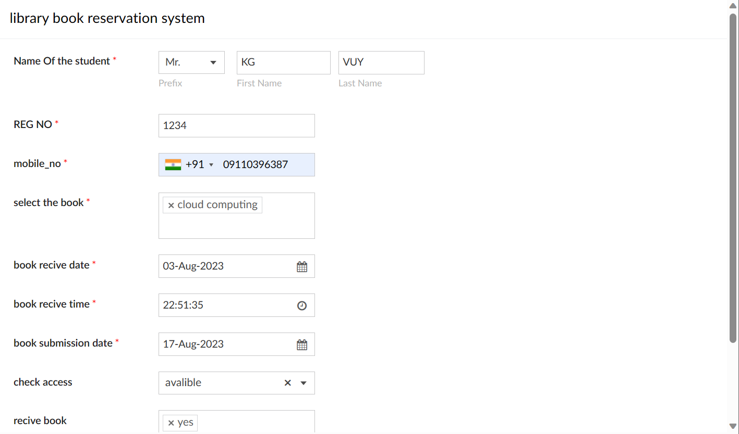

**OUTPUT:-**

